|  |  |  |  |  |
| --- | --- | --- | --- | --- |
| Fecha | Versión | Incidencias | Entrega | Comentario |
| 16/05/2023 | inicial | 5 | 15/05/2023 20:33 | Al ejecutar se están creando dos scripts de log, uno de ellos incorrecto. Además, se manda el contenido de este script a la LN y produce errores.  El parámetro con las líneas del log no tiene formato correcto |
| 19/05/2023 | v.2 | 3 | 19/05/2023 | Se corrigen las incidencias del log de ejecución. Ahora da problema al entregar los ficheros |
|  |  |  |  |  |

**PANTALLA EJECUTAR TYPE**

1. Falta el título de la pantalla de ejecutar

No solucionada

1. Ajustar el tamaño de las columnas de la pantalla de ejecutar.

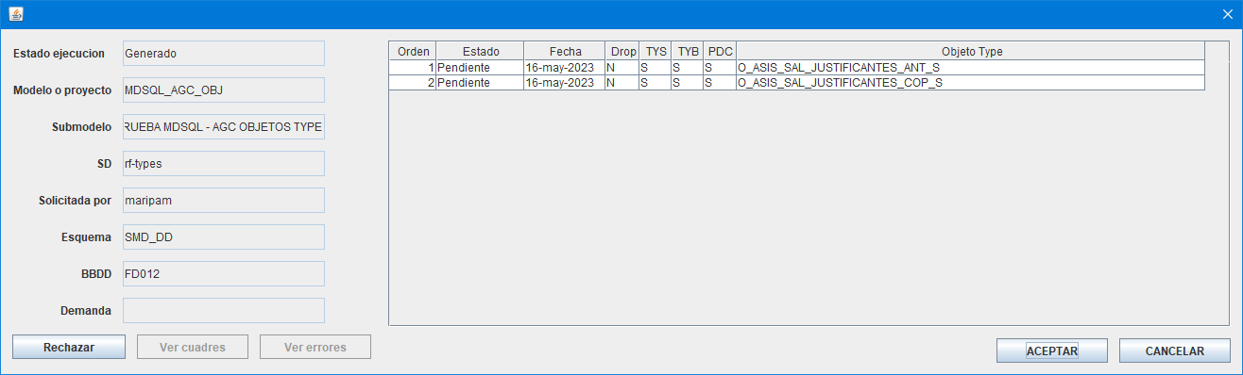 No solucionada

1. A la hora de entregar, se invoca correctamente a la lógica de negocio p_entregar_petición, y justo después da un error. No vemos que se hayan generado los ficheros .zip en la carpeta

11:46:01.672 [AWT-EventQueue-0] INFO c.m.u.l.PantallaResumenProcesadoActionListener - Zip file name: \\Nes011901-007\modelodatos\TEMPORAL_PUESTOS_VIRTUALES\MARIPAM\MDSQL_JAVA\pruebas\MDSQL_AGC_OBJ\null

Exception in thread "AWT-EventQueue-0" java.lang.NullPointerException

at com.mdsql.ui.listener.PantallaResumenProcesadoActionListener.createZip(PantallaResumenProcesadoActionListener.java:196)

at com.mdsql.ui.listener.PantallaResumenProcesadoActionListener.createZipVigente(PantallaResumenProcesadoActionListener.java:168)

at com.mdsql.ui.listener.PantallaResumenProcesadoActionListener.evtEntregar(PantallaResumenProcesadoActionListener.java:95)

at com.mdsql.ui.listener.PantallaResumenProcesadoActionListener.actionPerformed(PantallaResumenProcesadoActionListener.java:65)

at javax.swing.AbstractButton.fireActionPerformed(Unknown Source)

at javax.swing.AbstractButton$Handler.actionPerformed(Unknown Source)

at javax.swing.DefaultButtonModel.fireActionPerformed(Unknown Source)

at javax.swing.DefaultButtonModel.setPressed(Unknown Source)

at javax.swing.plaf.basic.BasicButtonListener.mouseReleased(Unknown Source)

at java.awt.Component.processMouseEvent(Unknown Source)

at javax.swing.JComponent.processMouseEvent(Unknown Source)

at java.awt.Component.processEvent(Unknown Source)

at java.awt.Container.processEvent(Unknown Source)

at java.awt.Component.dispatchEventImpl(Unknown Source)

at java.awt.Container.dispatchEventImpl(Unknown Source)

at java.awt.Component.dispatchEvent(Unknown Source)

at java.awt.LightweightDispatcher.retargetMouseEvent(Unknown Source)

at java.awt.LightweightDispatcher.processMouseEvent(Unknown Source)

at java.awt.LightweightDispatcher.dispatchEvent(Unknown Source)

at java.awt.Container.dispatchEventImpl(Unknown Source)

at java.awt.Window.dispatchEventImpl(Unknown Source)

at java.awt.Component.dispatchEvent(Unknown Source)

at java.awt.EventQueue.dispatchEventImpl(Unknown Source)

at java.awt.EventQueue.access$500(Unknown Source)

at java.awt.EventQueue$3.run(Unknown Source)

at java.awt.EventQueue$3.run(Unknown Source)

at java.security.AccessController.doPrivileged(Native Method)

at java.security.ProtectionDomain$JavaSecurityAccessImpl.doIntersectionPrivilege(Unknown Source)

at java.security.ProtectionDomain$JavaSecurityAccessImpl.doIntersectionPrivilege(Unknown Source)

at java.awt.EventQueue$4.run(Unknown Source)

at java.awt.EventQueue$4.run(Unknown Source)

at java.security.AccessController.doPrivileged(Native Method)

at java.security.ProtectionDomain$JavaSecurityAccessImpl.doIntersectionPrivilege(Unknown Source)

at java.awt.EventQueue.dispatchEvent(Unknown Source)

at java.awt.EventDispatchThread.pumpOneEventForFilters(Unknown Source)

at java.awt.EventDispatchThread.pumpEventsForFilter(Unknown Source)

at java.awt.EventDispatchThread.pumpEventsForFilter(Unknown Source)

at java.awt.WaitDispatchSupport$2.run(Unknown Source)

at java.awt.WaitDispatchSupport$4.run(Unknown Source)

at java.awt.WaitDispatchSupport$4.run(Unknown Source)

at java.security.AccessController.doPrivileged(Native Method)

at java.awt.WaitDispatchSupport.enter(Unknown Source)

at java.awt.Dialog.show(Unknown Source)

at java.awt.Component.show(Unknown Source)

at java.awt.Component.setVisible(Unknown Source)

at java.awt.Window.setVisible(Unknown Source)

at java.awt.Dialog.setVisible(Unknown Source)

at com.mdval.ui.utils.UIHelper.show(UIHelper.java:63)

at com.mdsql.ui.listener.FramePrincipalActionListener.evtEjecutar(FramePrincipalActionListener.java:452)

at com.mdsql.ui.listener.FramePrincipalActionListener.actionPerformed(FramePrincipalActionListener.java:94)

at javax.swing.AbstractButton.fireActionPerformed(Unknown Source)

at javax.swing.AbstractButton$Handler.actionPerformed(Unknown Source)

at javax.swing.DefaultButtonModel.fireActionPerformed(Unknown Source)

at javax.swing.DefaultButtonModel.setPressed(Unknown Source)

at javax.swing.plaf.basic.BasicButtonListener.mouseReleased(Unknown Source)

at java.awt.AWTEventMulticaster.mouseReleased(Unknown Source)

at java.awt.Component.processMouseEvent(Unknown Source)

at javax.swing.JComponent.processMouseEvent(Unknown Source)

at java.awt.Component.processEvent(Unknown Source)

at java.awt.Container.processEvent(Unknown Source)

at java.awt.Component.dispatchEventImpl(Unknown Source)

at java.awt.Container.dispatchEventImpl(Unknown Source)

at java.awt.Component.dispatchEvent(Unknown Source)

at java.awt.LightweightDispatcher.retargetMouseEvent(Unknown Source)

at java.awt.LightweightDispatcher.processMouseEvent(Unknown Source)

at java.awt.LightweightDispatcher.dispatchEvent(Unknown Source)

at java.awt.Container.dispatchEventImpl(Unknown Source)

at java.awt.Window.dispatchEventImpl(Unknown Source)

at java.awt.Component.dispatchEvent(Unknown Source)

at java.awt.EventQueue.dispatchEventImpl(Unknown Source)

at java.awt.EventQueue.access$500(Unknown Source)

at java.awt.EventQueue$3.run(Unknown Source)

at java.awt.EventQueue$3.run(Unknown Source)

at java.security.AccessController.doPrivileged(Native Method)

at java.security.ProtectionDomain$JavaSecurityAccessImpl.doIntersectionPrivilege(Unknown Source)

at java.security.ProtectionDomain$JavaSecurityAccessImpl.doIntersectionPrivilege(Unknown Source)

at java.awt.EventQueue$4.run(Unknown Source)

at java.awt.EventQueue$4.run(Unknown Source)

at java.security.AccessController.doPrivileged(Native Method)

at java.security.ProtectionDomain$JavaSecurityAccessImpl.doIntersectionPrivilege(Unknown Source)

at java.awt.EventQueue.dispatchEvent(Unknown Source)

at java.awt.EventDispatchThread.pumpOneEventForFilters(Unknown Source)

at java.awt.EventDispatchThread.pumpEventsForFilter(Unknown Source)

at java.awt.EventDispatchThread.pumpEventsForHierarchy(Unknown Source)

at java.awt.EventDispatchThread.pumpEvents(Unknown Source)

at java.awt.EventDispatchThread.pumpEvents(Unknown Source)

at java.awt.EventDispatchThread.run(Unknown Source)